TPIZZA SALES SQL QUERIES
- KPI’S
- PIZZA_SALES TABLE
SELECT * FROM pizza_sales

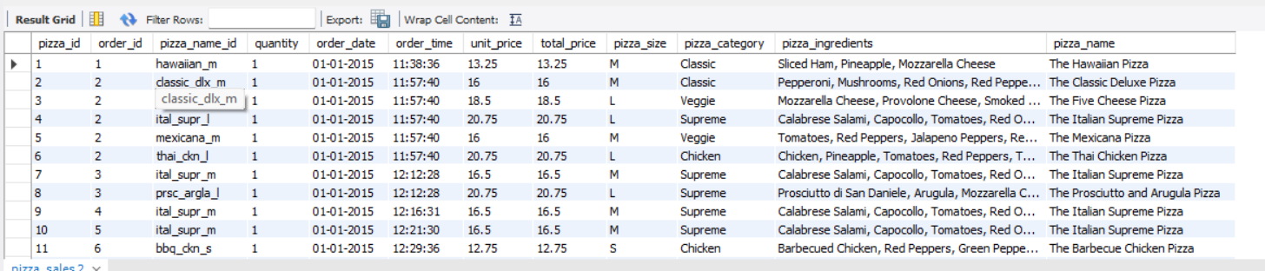
- TOTAL REVENUE
SELECT ROUND(SUM(total_price) ,2) AS TOTAL_REVENUE
FROM pizza_sales;

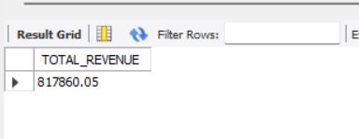

- AVERAGE ORDER VALUE

SELECT ROUND(SUM(total_price)/COUNT(DISTINCT Order_id) ,2) AS AVERAGE_ORDER_VALUE
FROM pizza_sales;

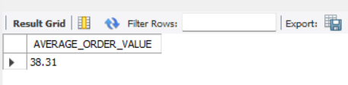

- TOTAL PIZZA SOLD
SELECT SUM(QUANTITY) AS TOTAL_PIZZA_SOLD
FROM PIZZA_SALES;

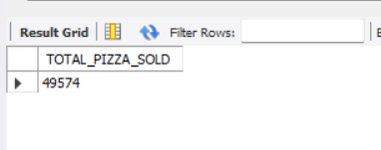
- TOTAL ORDERS

SELECT COUNT(DISTINCT(Order_id)) AS TOTAL_OEDERS
FROM PIZZA_SALES;

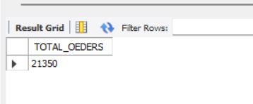

- AVERAGE PIZZAS PER ORDER

SELECT ROUND(SUM(QUANTITY)/CAST(COUNT(DISTINCT Order_id) AS DECIMAL),2) AS TOTAL_PIZZAS_PER_ORDER
FROM PIZZA_SALES;

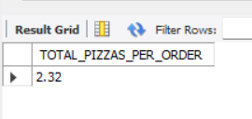

B. DAILY TREND FOR ORDERS (FROM PostgreSQL)
SELECT to_char(order_date,'Day') AS DAY, COUNT(DISTINCT order_id) AS Total_orders
FROM pizza_sales
GROUP BY to_char(order_date,'Day')
ORDER BY total_orders DESC

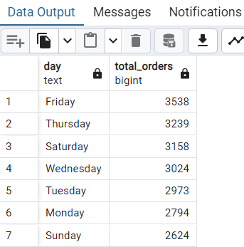

c. HOURLY TREND FOR ORDERS
SELECT EXTRACT(HOUR FROM order_time) AS ORDER_HOUR,
COUNT(DISTINCT order_id) as TOTAL_ORDERS FROM pizza_sales
GROUP BY EXTRACT(HOUR FROM order_time)
ORDER BY EXTRACT(HOUR FROM order_time);

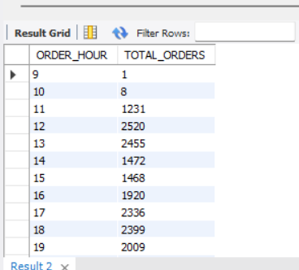

D. PERCENTAGE OF SALES BY PIZZA CUTEGORY
SELECT pizza_category,ROUND(SUM(total_price),2) AS TOTAL_SALES,
ROUND((SUM(total_price)/(SELECT SUM(total_price) FROM pizza_sales
))*100,2)AS PCT
FROM pizza_sales
GROUP BY pizza_category;

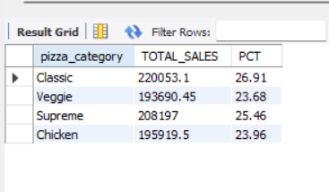

E. PERCENTAGE OF sales BY PIZZA SIZE
SELECT pizza_size, ROUND(SUM(total_price), 2) AS Total_sales,
ROUND((SUM(total_price) / (
SELECT SUM(total_price) FROM pizza_sales
WHERE QUARTER(STR_TO_DATE(order_date, '%Y-%m-%d')) = 4
)) * 100, 2) AS PCT
FROM pizza_sales
WHERE QUARTER(STR_TO_DATE(order_date, '%Y-%m-%d')) = 4
GROUP BY pizza_size
ORDER BY PCT DESC;

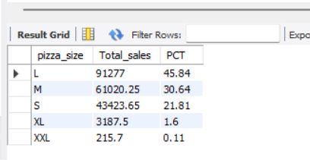
F. TOTAL PIZZA SOLD BY PIZZA_CATEGORY
SELECT pizza_category, SUM(quantity) AS NO_OF_PIZZA_SOLD
FROM pizza_sales
GROUP BY pizza_category;

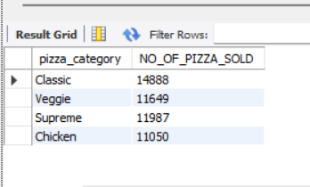

G. TOP 5 BEST PIZZA SELLERS BY TOTAL PIZZA SOLD

Top 5 best pizza sellers (for 1st month i.e. January)

SELECT pizza_name, SUM(quantity) AS TOTAL_PIZZA_SOLD
FROM pizza_sales
WHERE MONTH(STR_TO_DATE(order_date,'%d-%m-%y'))=1
GROUP BY pizza_name
ORDER BY TOTAL_PIZZA_SOLD DESC
LIMIT 5;

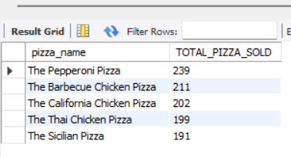

FOR THE MONTH OF JANUARY
H. BOTTOM 5 WORST SELLERS BY TOTAL PIZZA_SOLD

SELECT pizza_name, SUM(quantity) AS TOTAL_PIZZA_SOLD
FROM pizza_sales
WHERE MONTH(STR_TO_DATE(order_date,'%d-%m-%y'))=1
GROUP BY pizza_name
ORDER BY TOTAL_PIZZA_SOLD ASC
LIMIT 5;

